My New Class
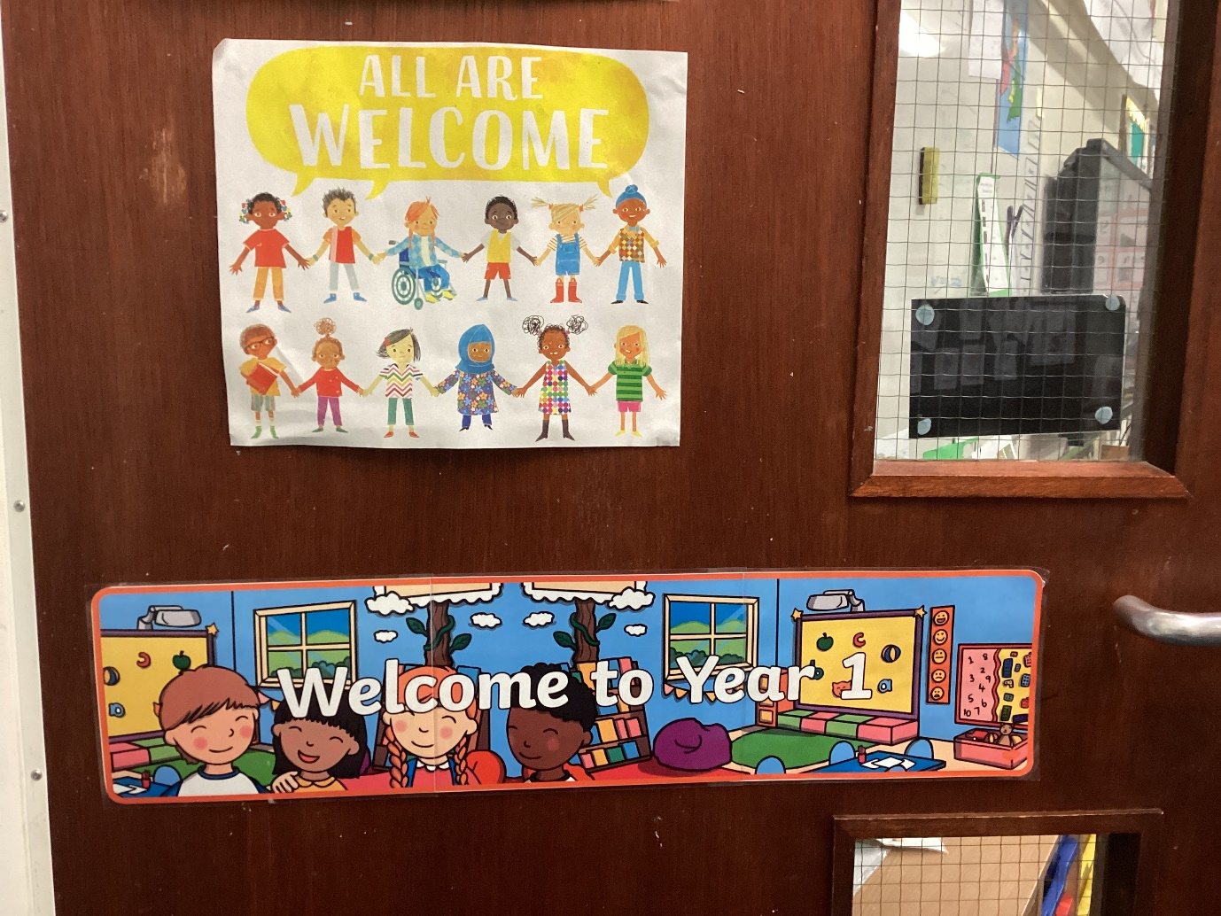

This book belongs to …………………………………………………
When I come back to school, I will be in Class 1.
My new teacher will be …
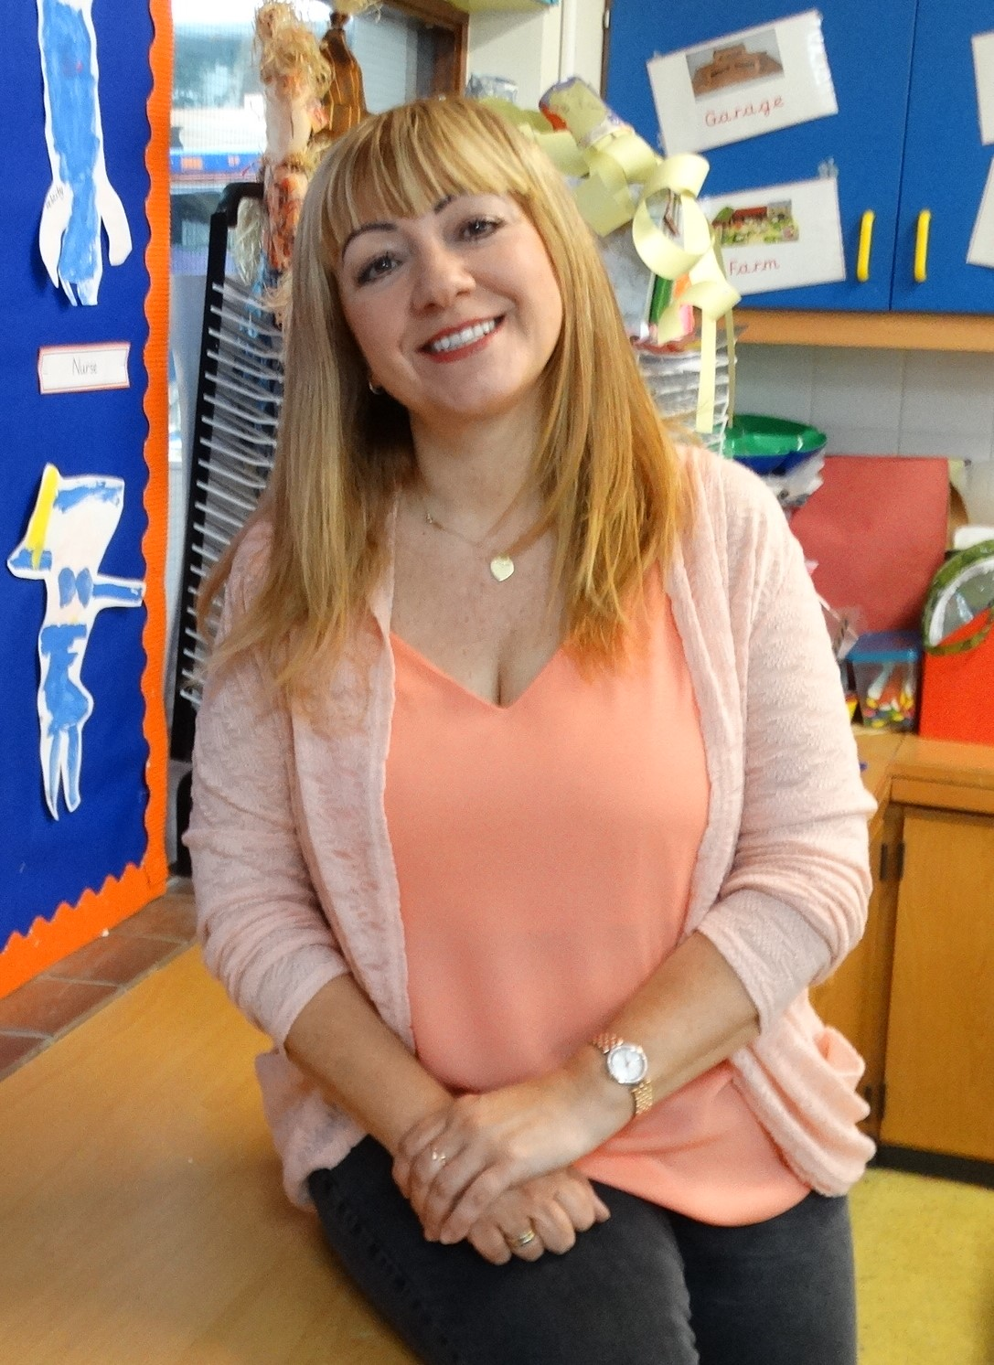
Miss Bowen

Mrs Berrow

My teaching assistants will be
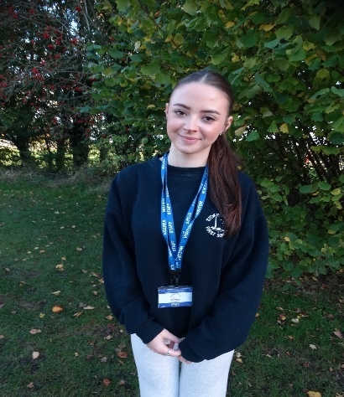

Miss Johnson
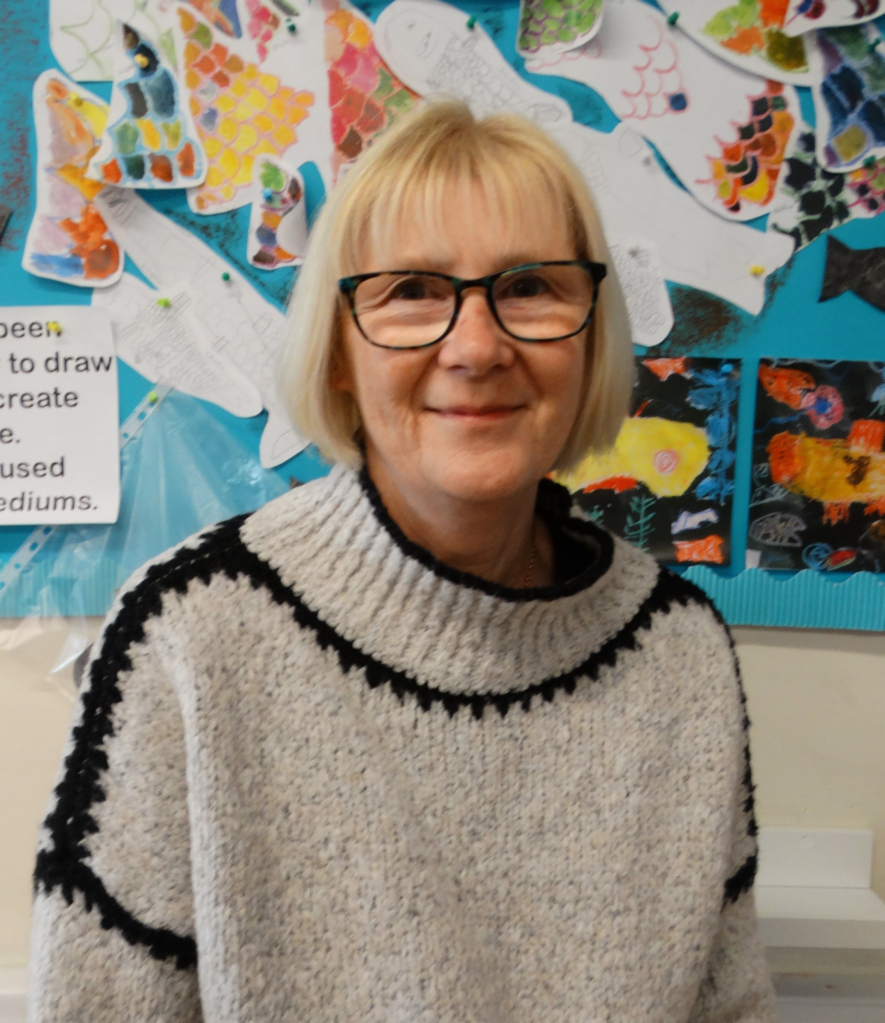

Mrs Holloway

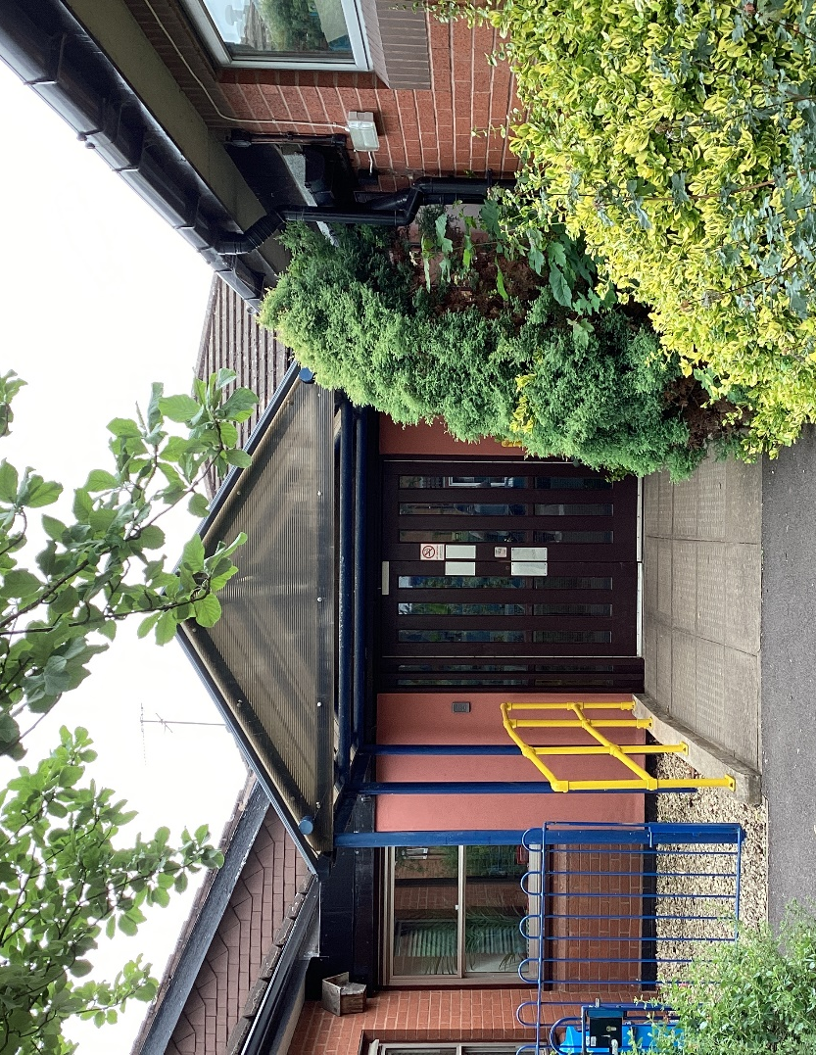
I will enter and leave school using this door.

When I arrive in school, I will leave my coat, P.E. bag and rucksack in one of the cloakrooms…
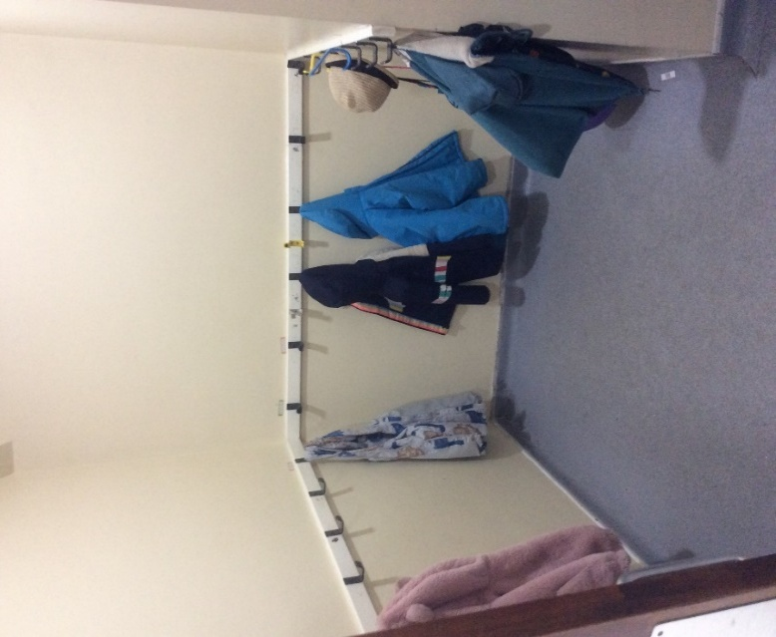
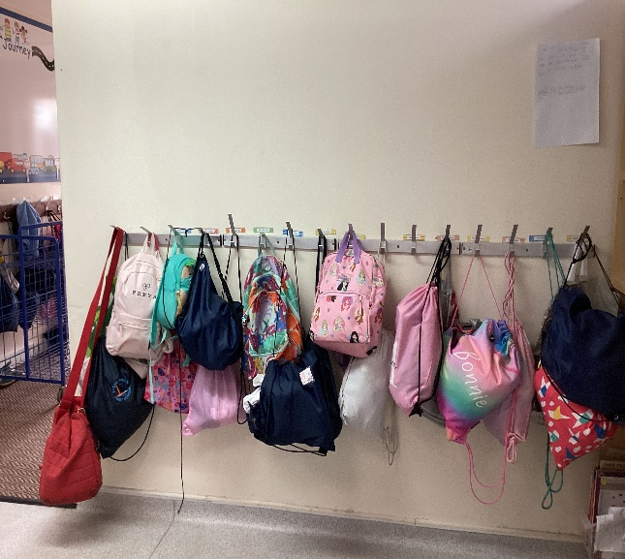

and go into my new classroom

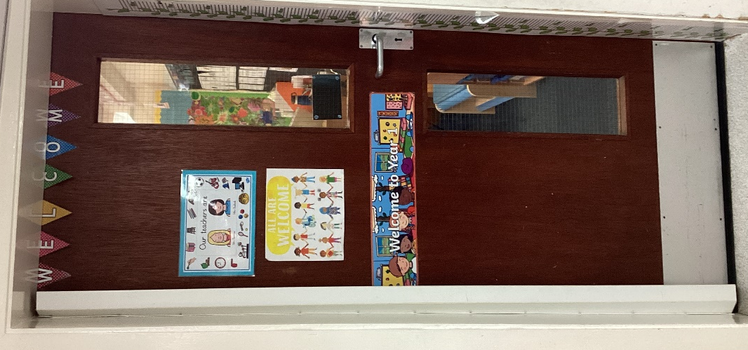

This is where I will find my tray. My new tray will have my name on.

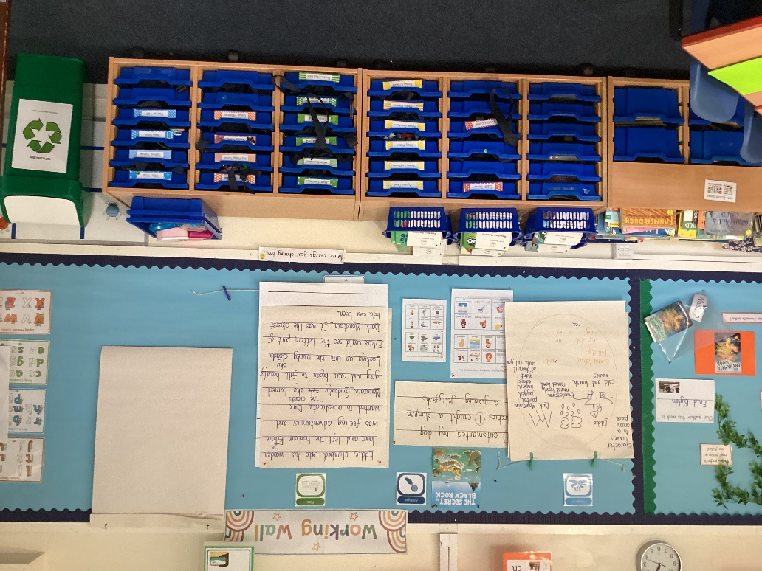

I will sit at tables like these
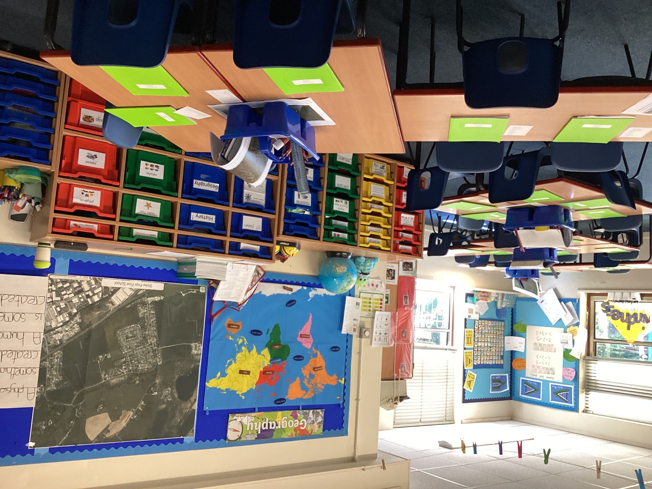

This is where you’ll find our
reading and browsing books

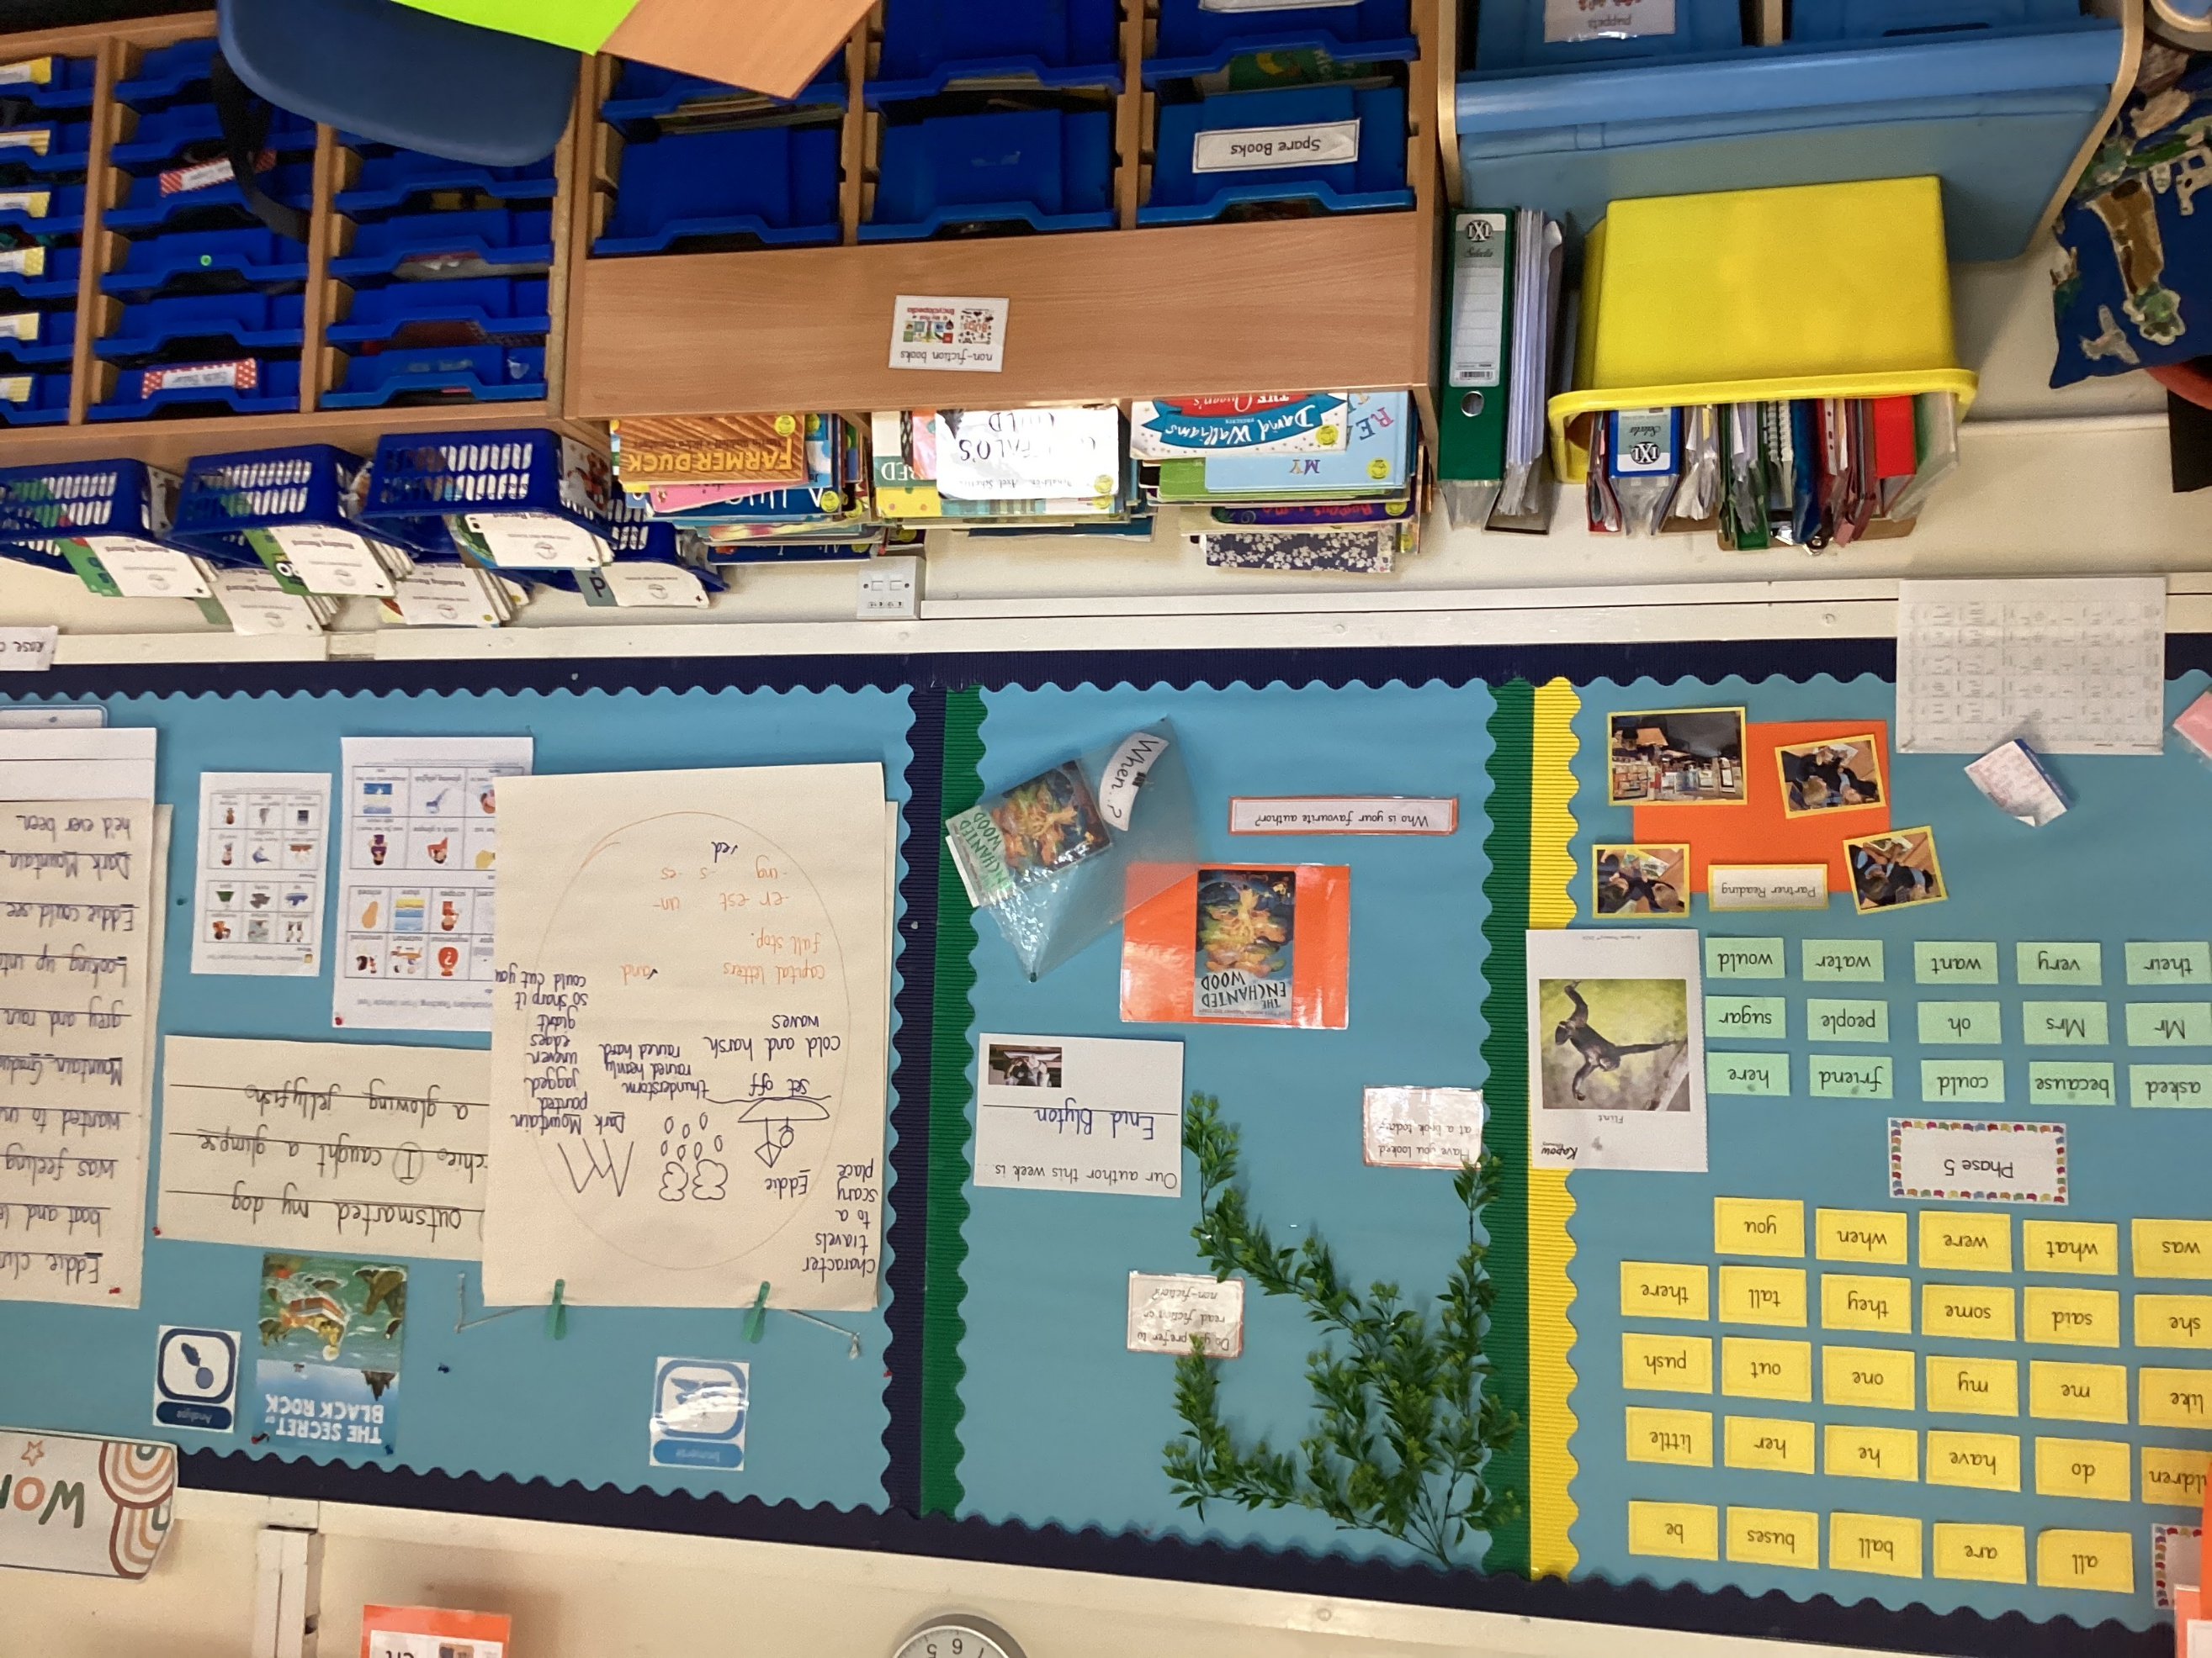
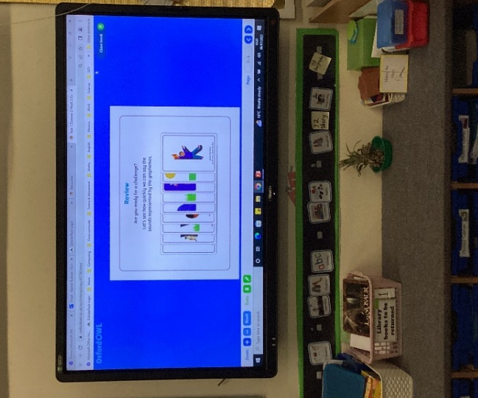

This is the interactive white board.

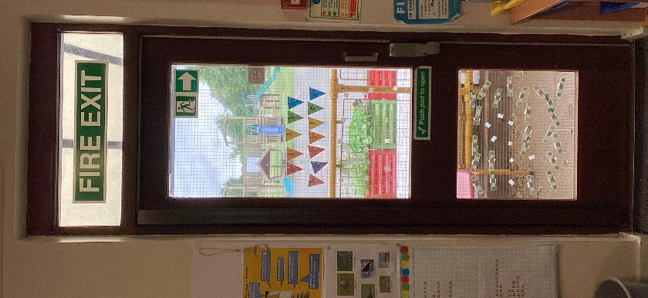
This is the door to go out to play.

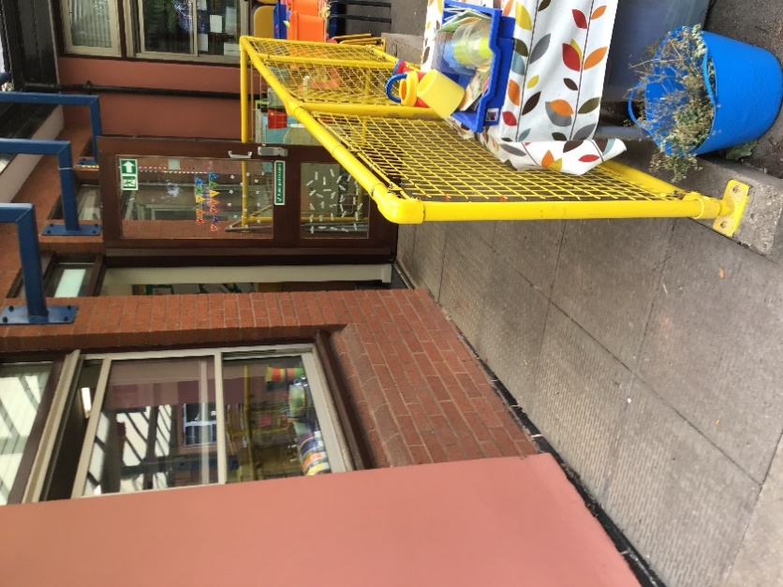
We go back into the classroom through this door

This page is for me to write any questions I would like to ask about being in Class 1.
……………………………………………………………………………………………………………………………………………………………………………………………………………………………………………………………………………………………………………………………………………………………………………………………………………………………………………………………………………………………………………………………………………………………………………………………………………………………………………………………………………………………………………………………………………………………………………………………………………………………………………………………………………………………………………………………………………………………………………………………………………………………………………………………………………………………………………………………………………………………………………………………………………………………………………………………………………………………………………………………………………………………………………………………………………………………………………………………………………………………………………………………………………………………………………………………………………………………………………………………………………………………………………………………………………………………………………………………………………………………………………………………………………………………………………………………………………………………………………………………………………………………………………………………………………………

Being in Class 1 will be FUN !!!

