My New Class

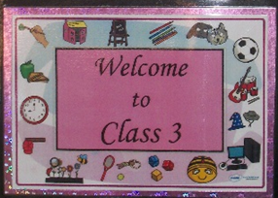

This book belongs to ……………………………………………………………………

When I return to school, I will be in Year 3.

Your new teacher will be…

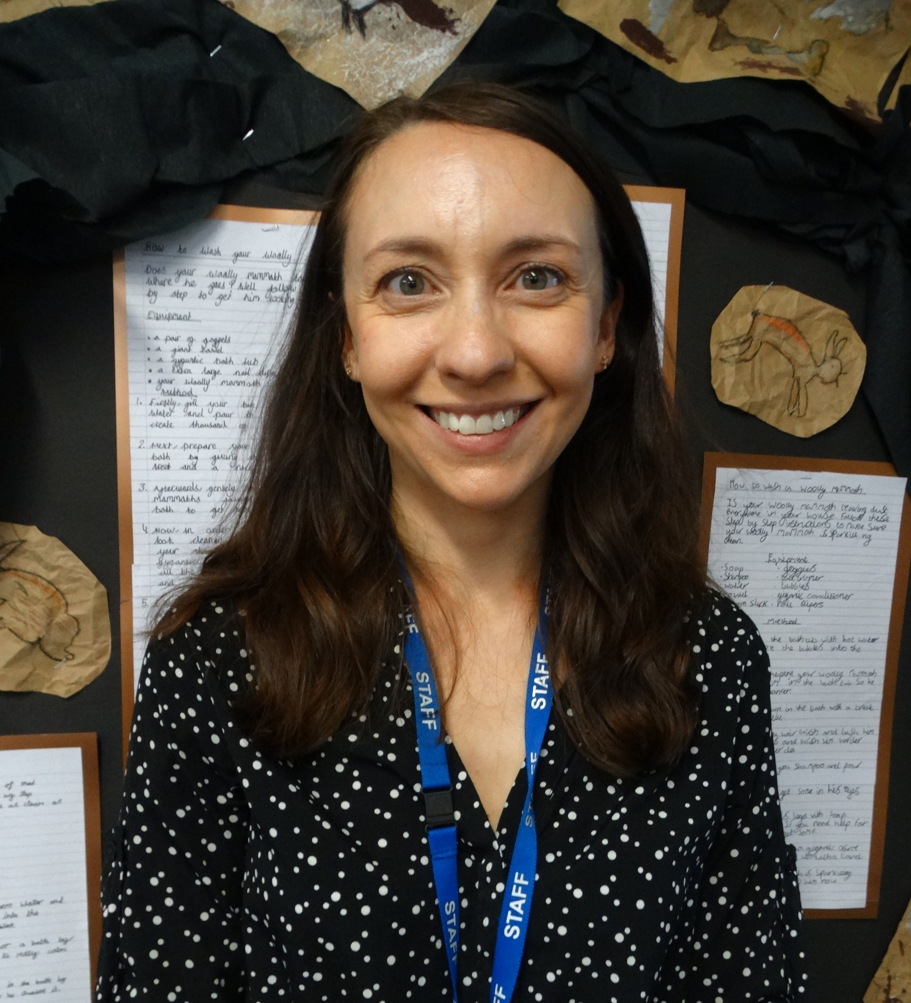
Mrs Davis

Teaching Assistants will be…

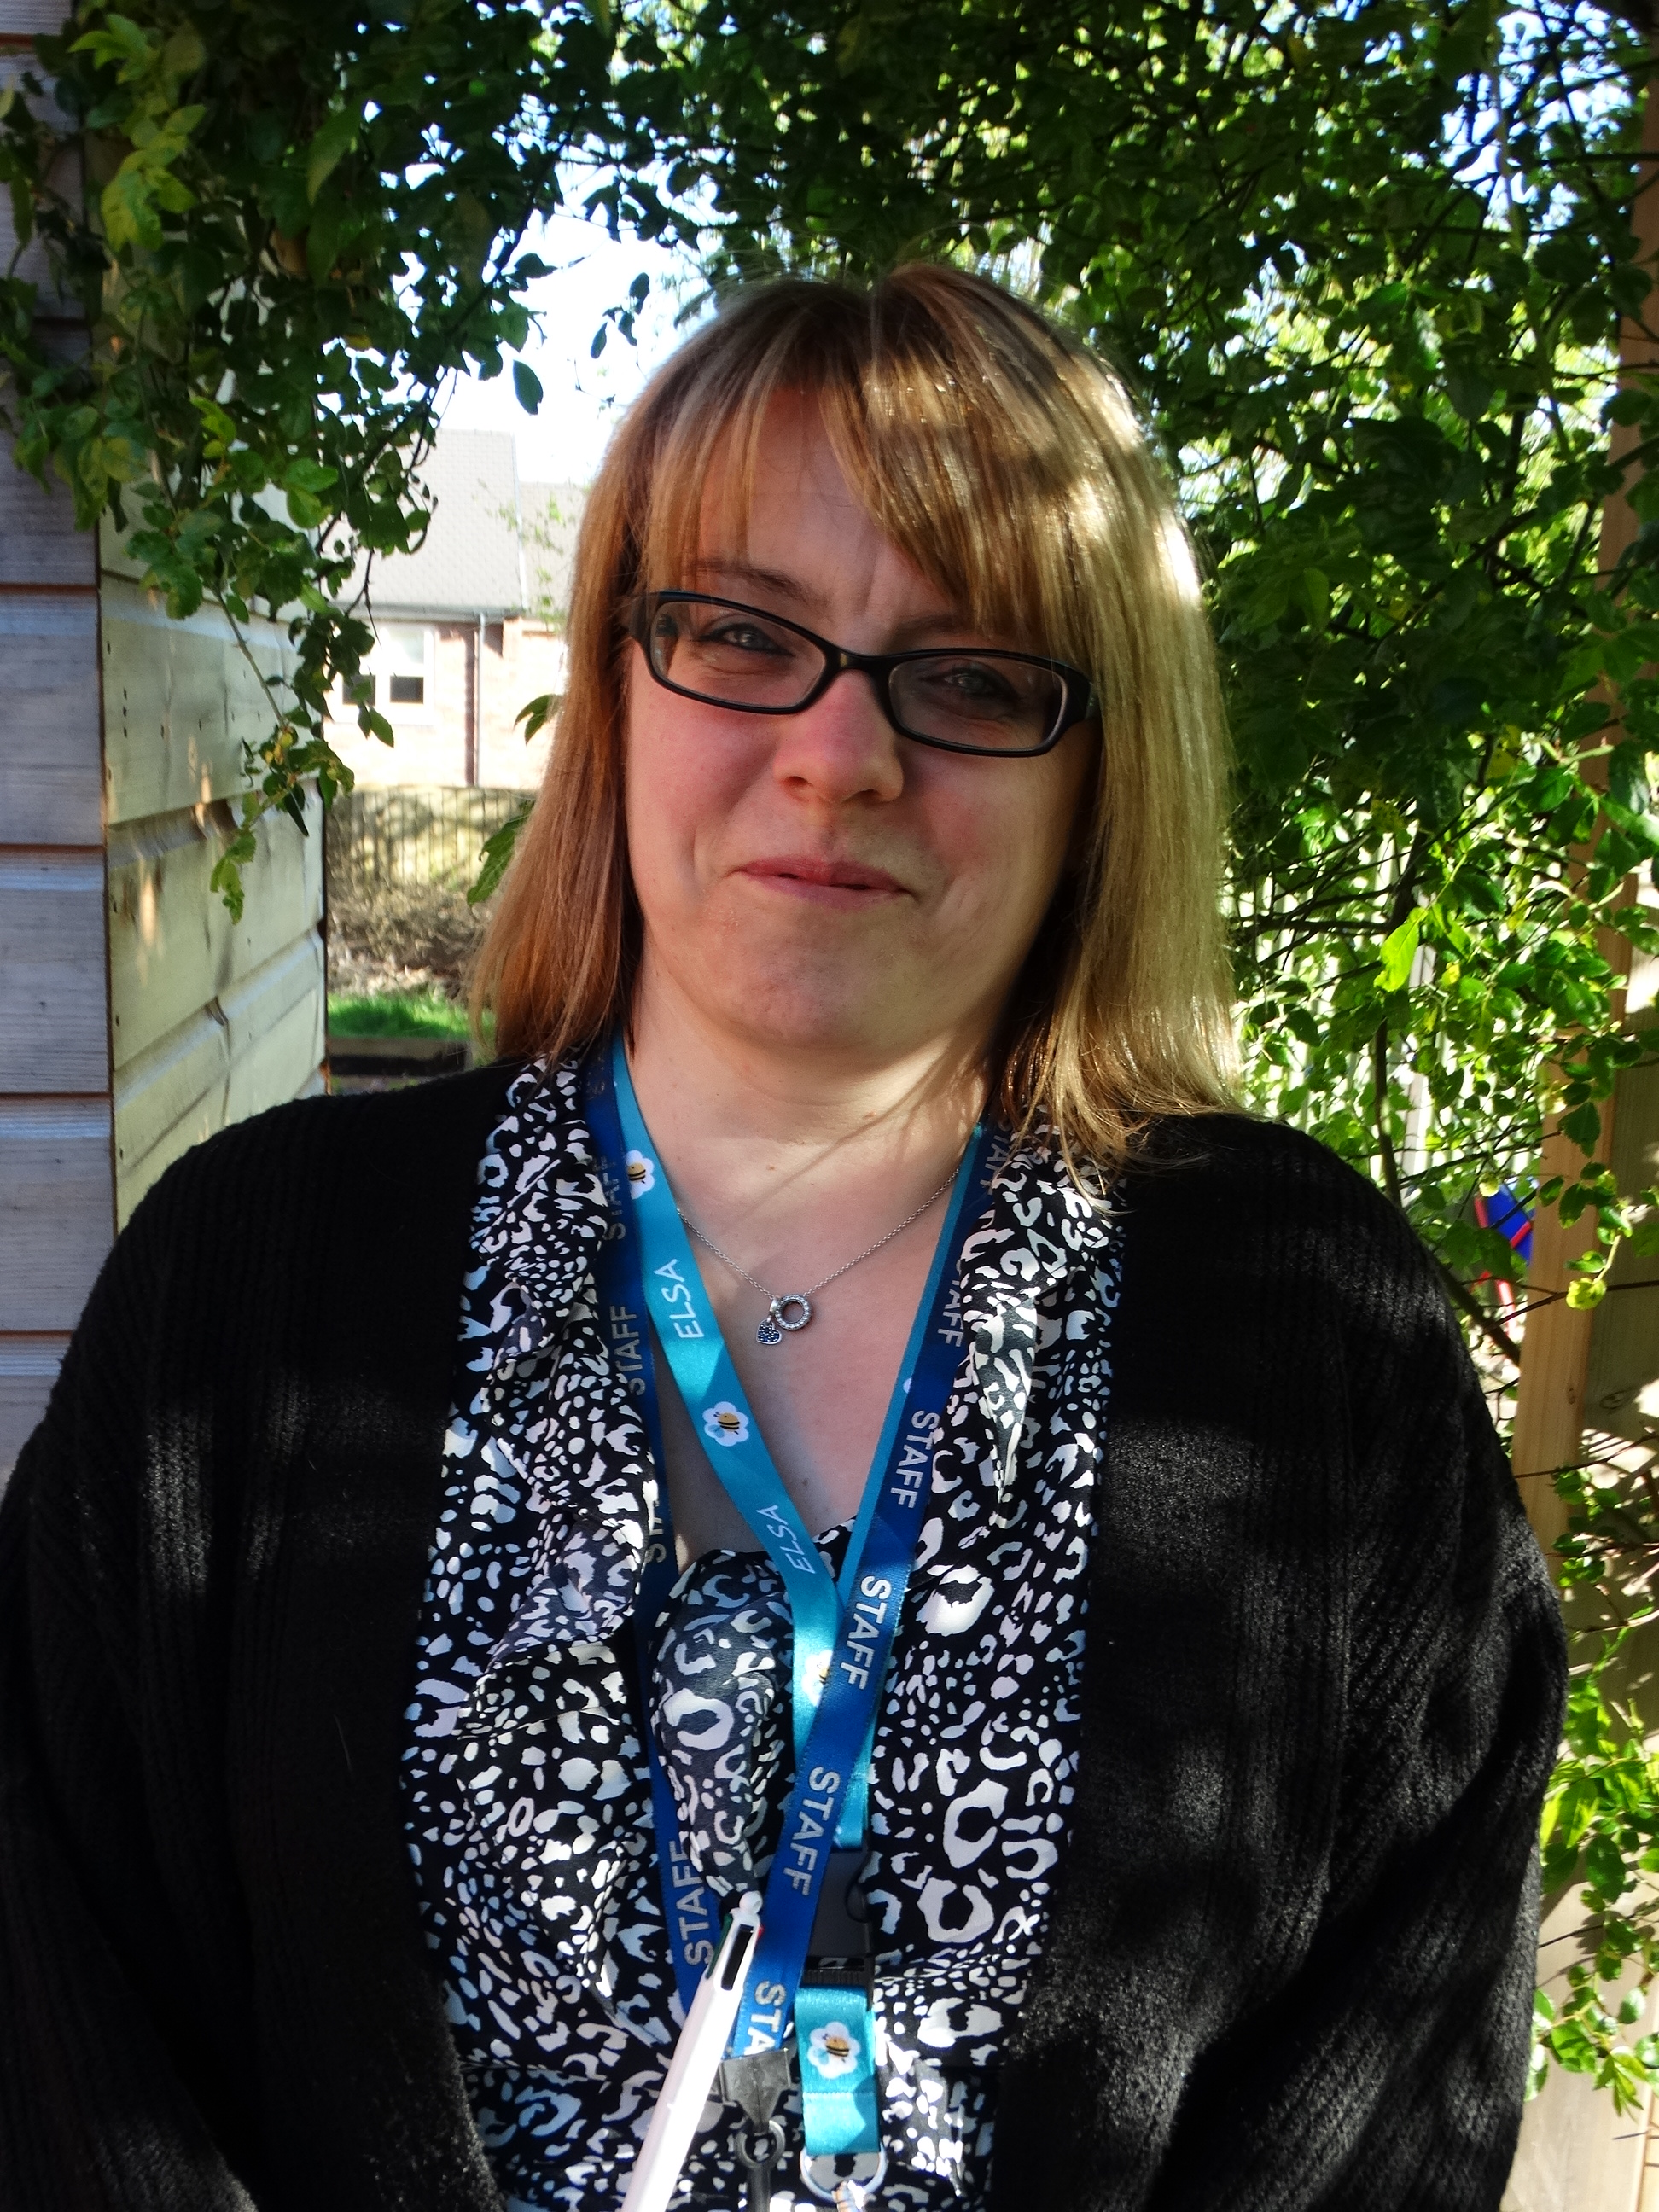
Mrs Harris

We come through the main door every morning.
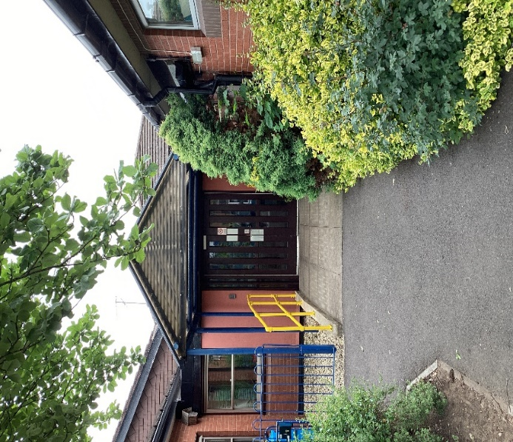

This is the entrance we use to leave school at the end of the day.
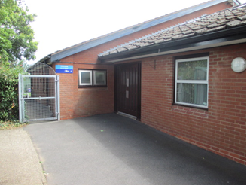

When I arrive at school, I will leave my coat and bag here…
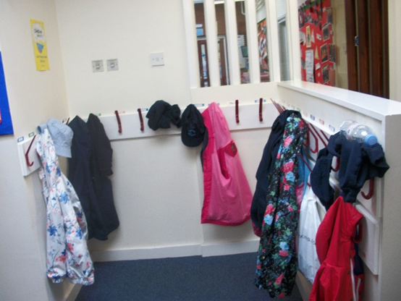

… and go into my new classroom.
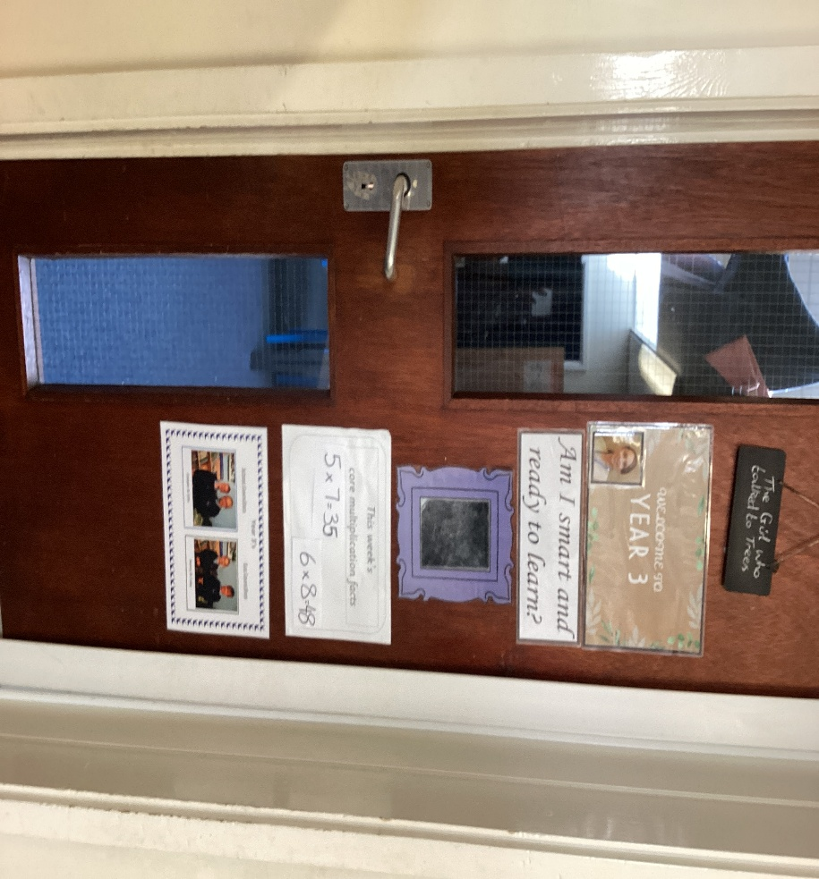

This is where I will find my tray. My new tray will have my name on it.

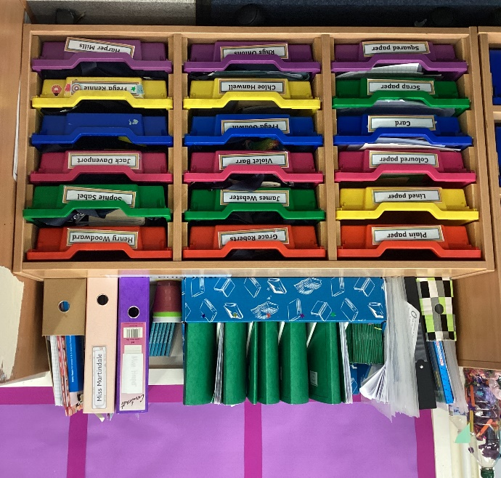

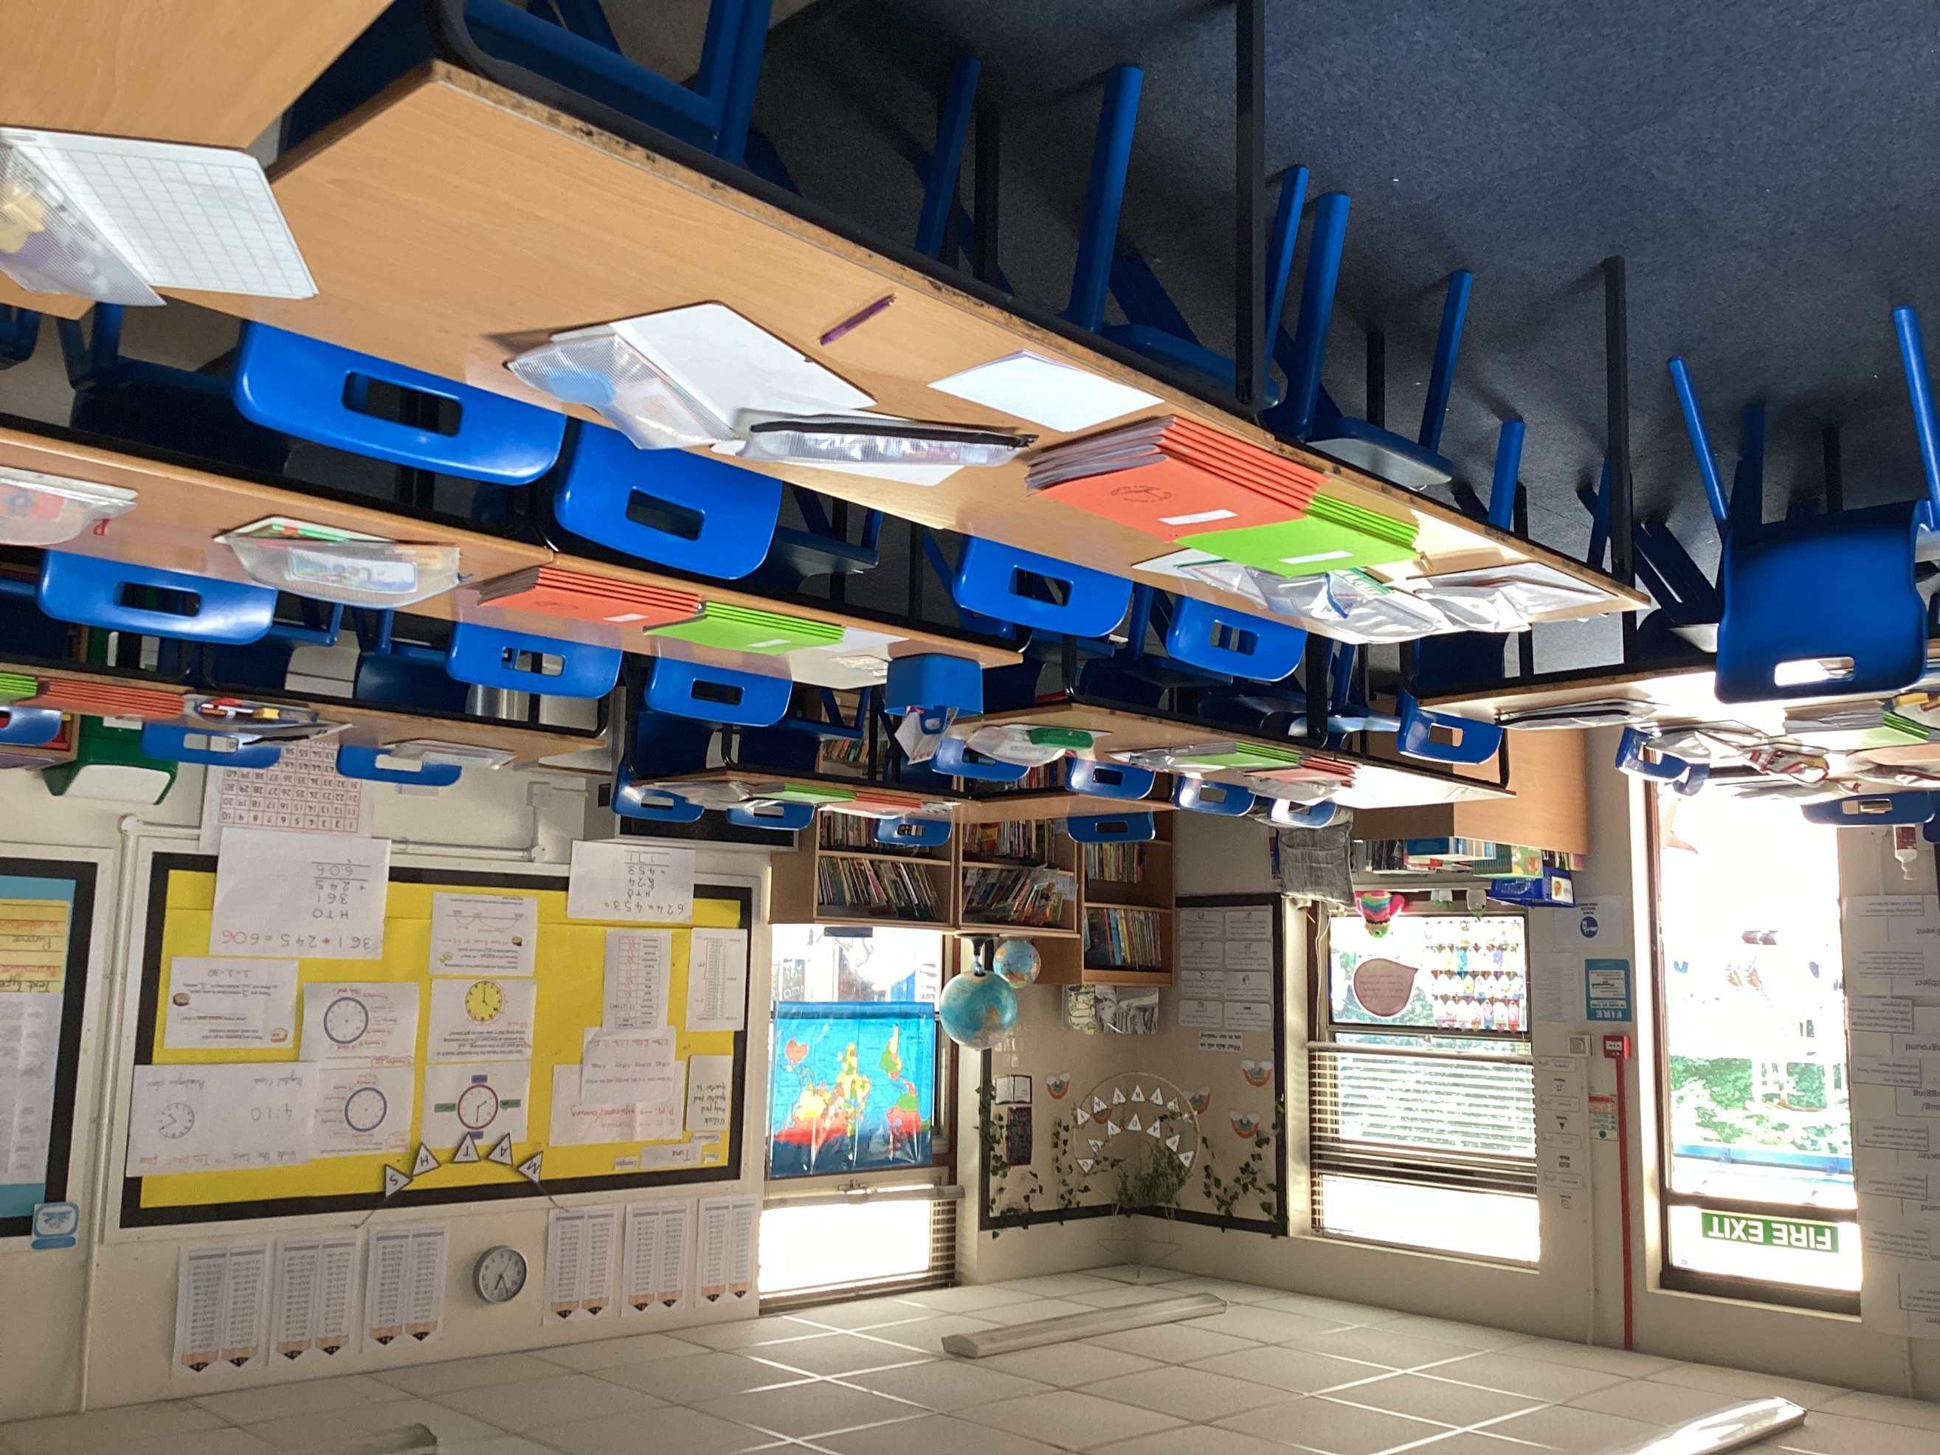

I will sit at tables like these

Here are some other pictures from my new classroom.

The Interactive White Board.
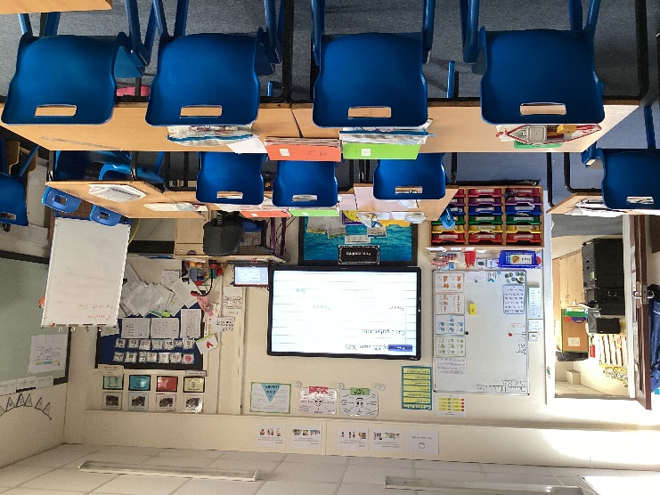
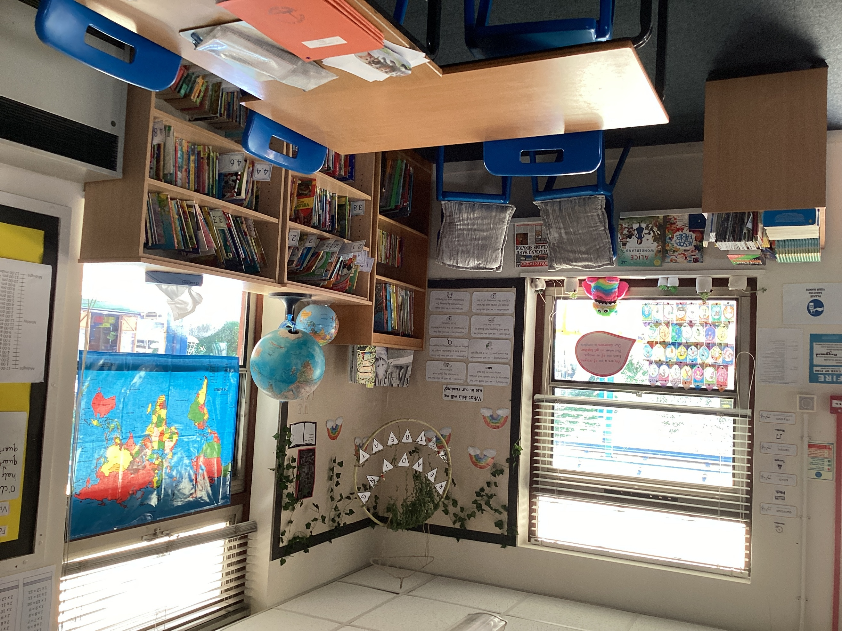

The Book Corner

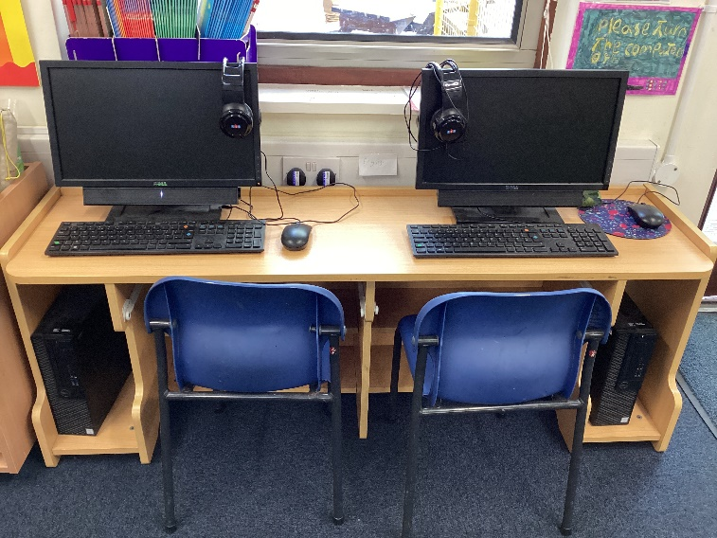
The classroom computers.

This is the door which leads out onto the playground.

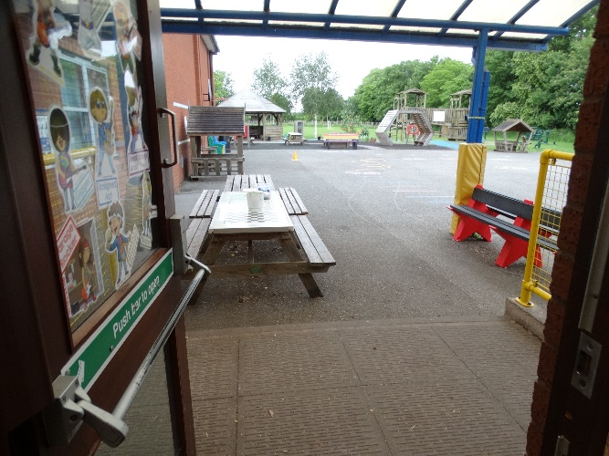
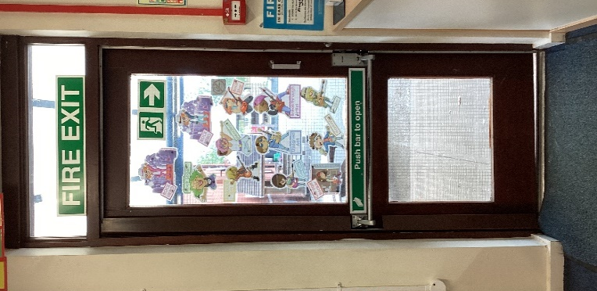

We go into the classroom through this door.
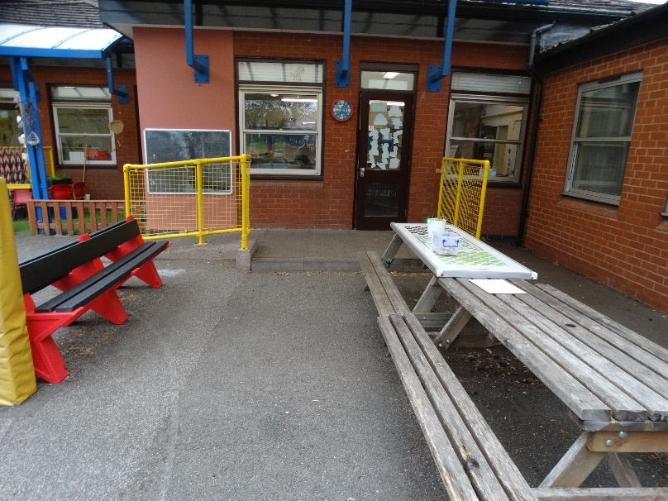

This page is for me to write any questions I might have about Class 3.
……………………………………………………………………………………………………………………………………………………………………………………………………………………………………………………………………………………………………………………………………………………………………………………………………………………………………………………………………………………………………………………………………………………………………………………………………………………………………………………………………………………………………………………………………………………………………………………………………………………………………………………………………………………………………………………………………………………………………………………………………………………………………………………………………………………………………………………………………………………………………………………………………………………………………………………………………………………………………………………………………………………………………………………………………………………………………………………………………………
Being in Class 3 will be FUN and EXCITING!!

