My New Class

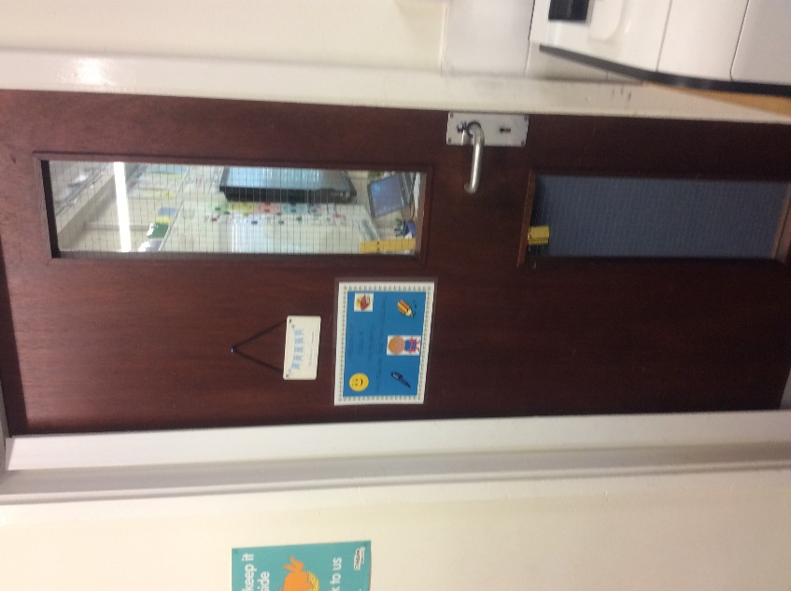

Welcome to Year 4

This book belongs to ………………………………………………………………………
When I return to school, I will be in Class 4.
My new teacher will be …

Mr Gregory

My new Teaching Assistants will be ….

Mrs Moss

Photo to follow
shortly

Mrs Moss
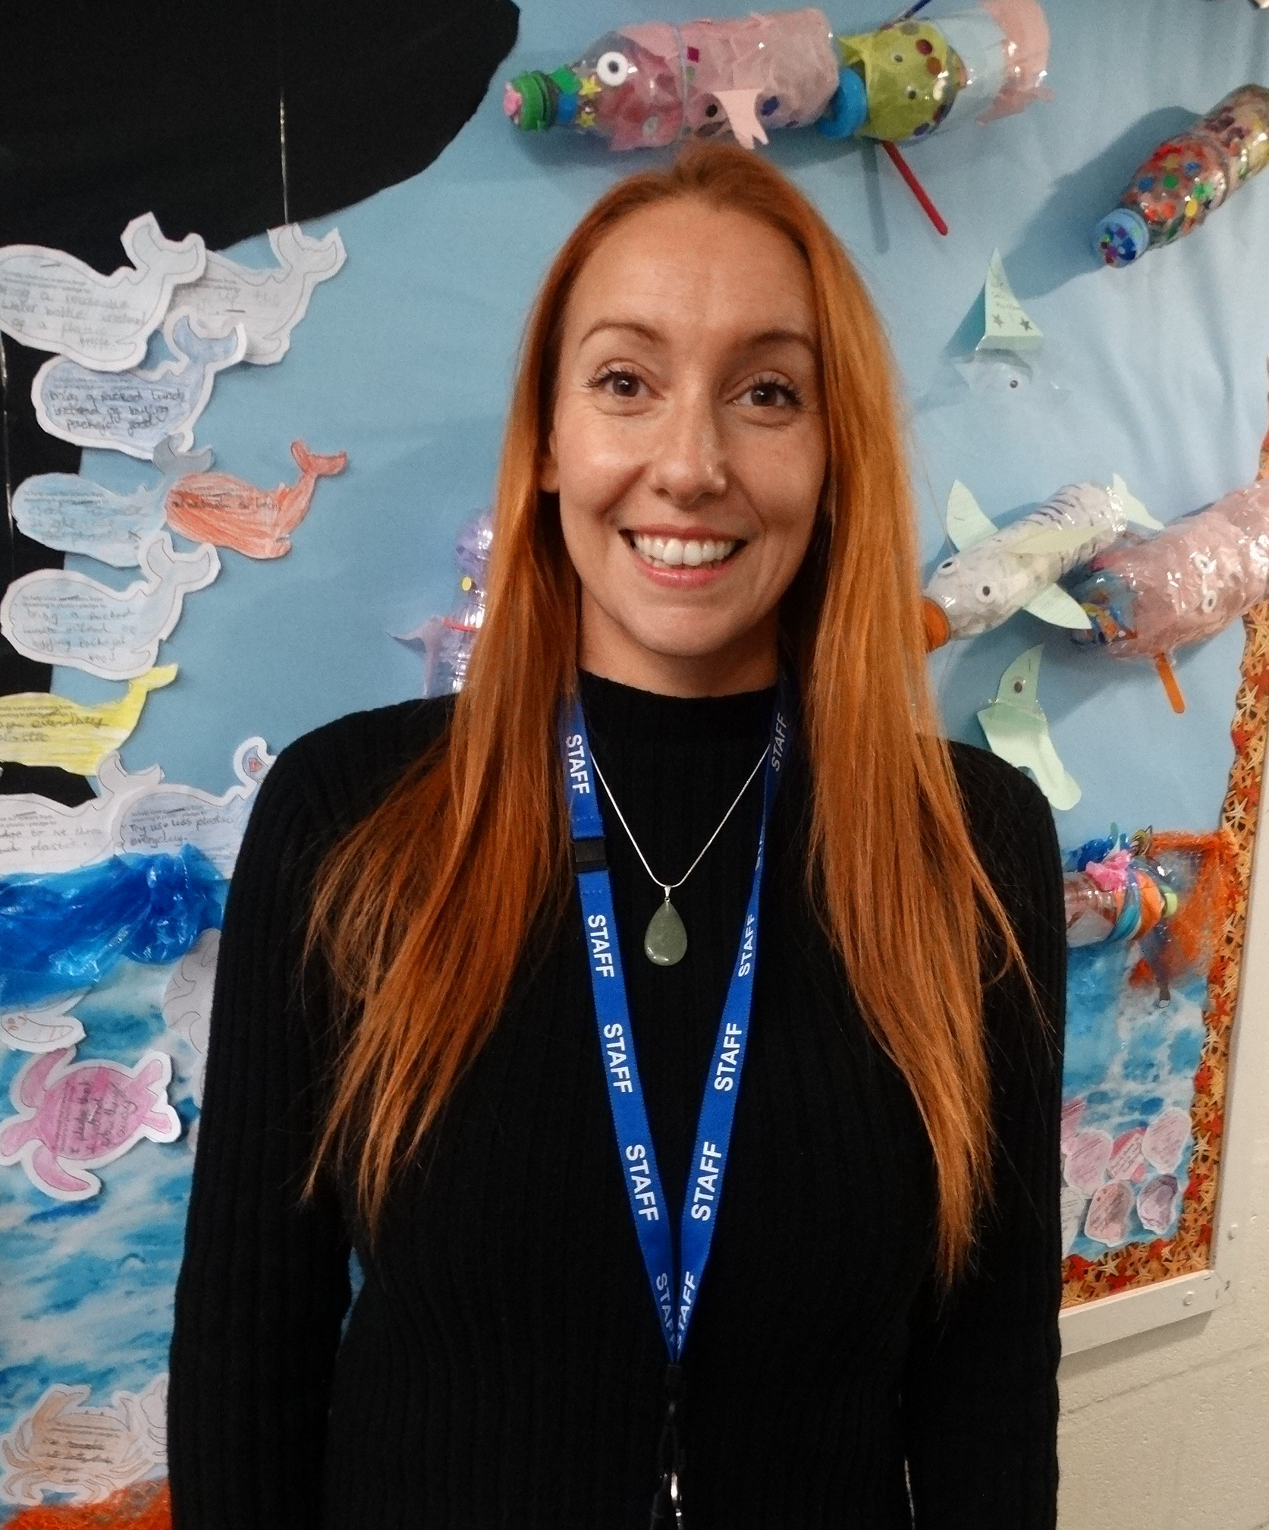
Mrs Lowe

Our 1 to 1 teaching assistant is 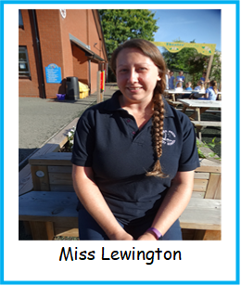

When I arrive in school, I will leave my coat and my bag in this cloakroom. The door to the cloakroom is through the Hall.
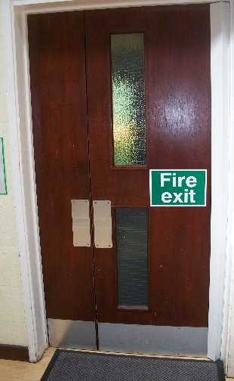
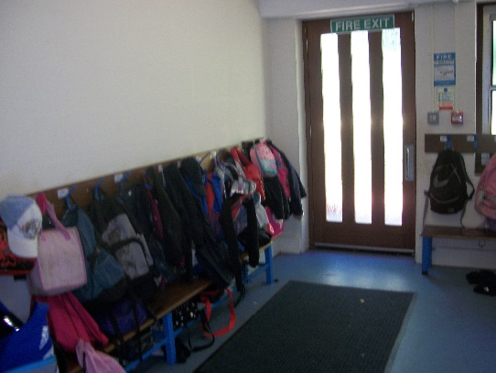

I will hang up my coat and items I don’t need in the classroom, and take my reading book, reading diary and water bottle with me up to my new classroom.
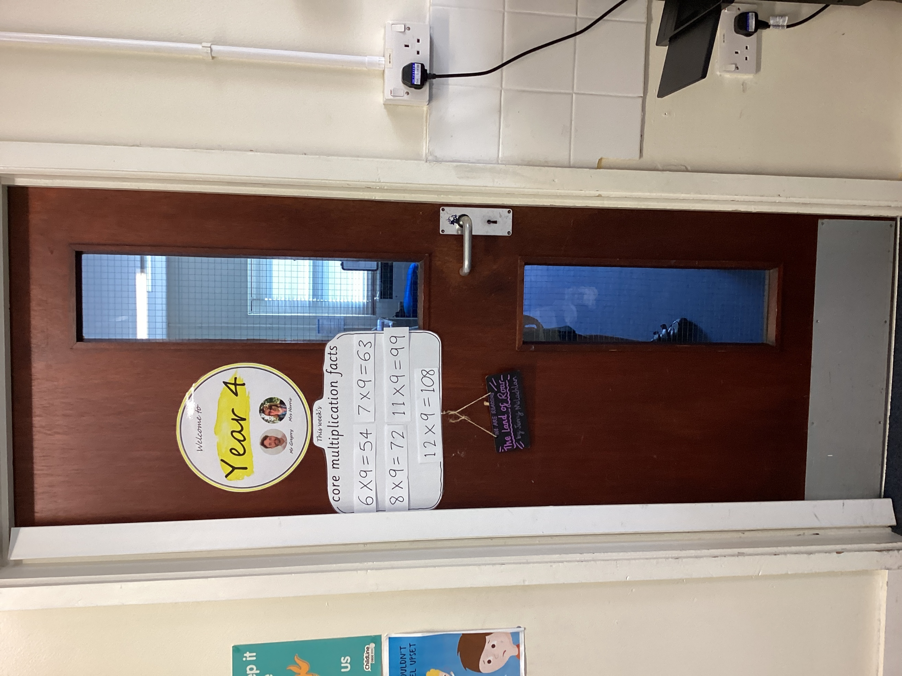

My new tray will have my name on it.
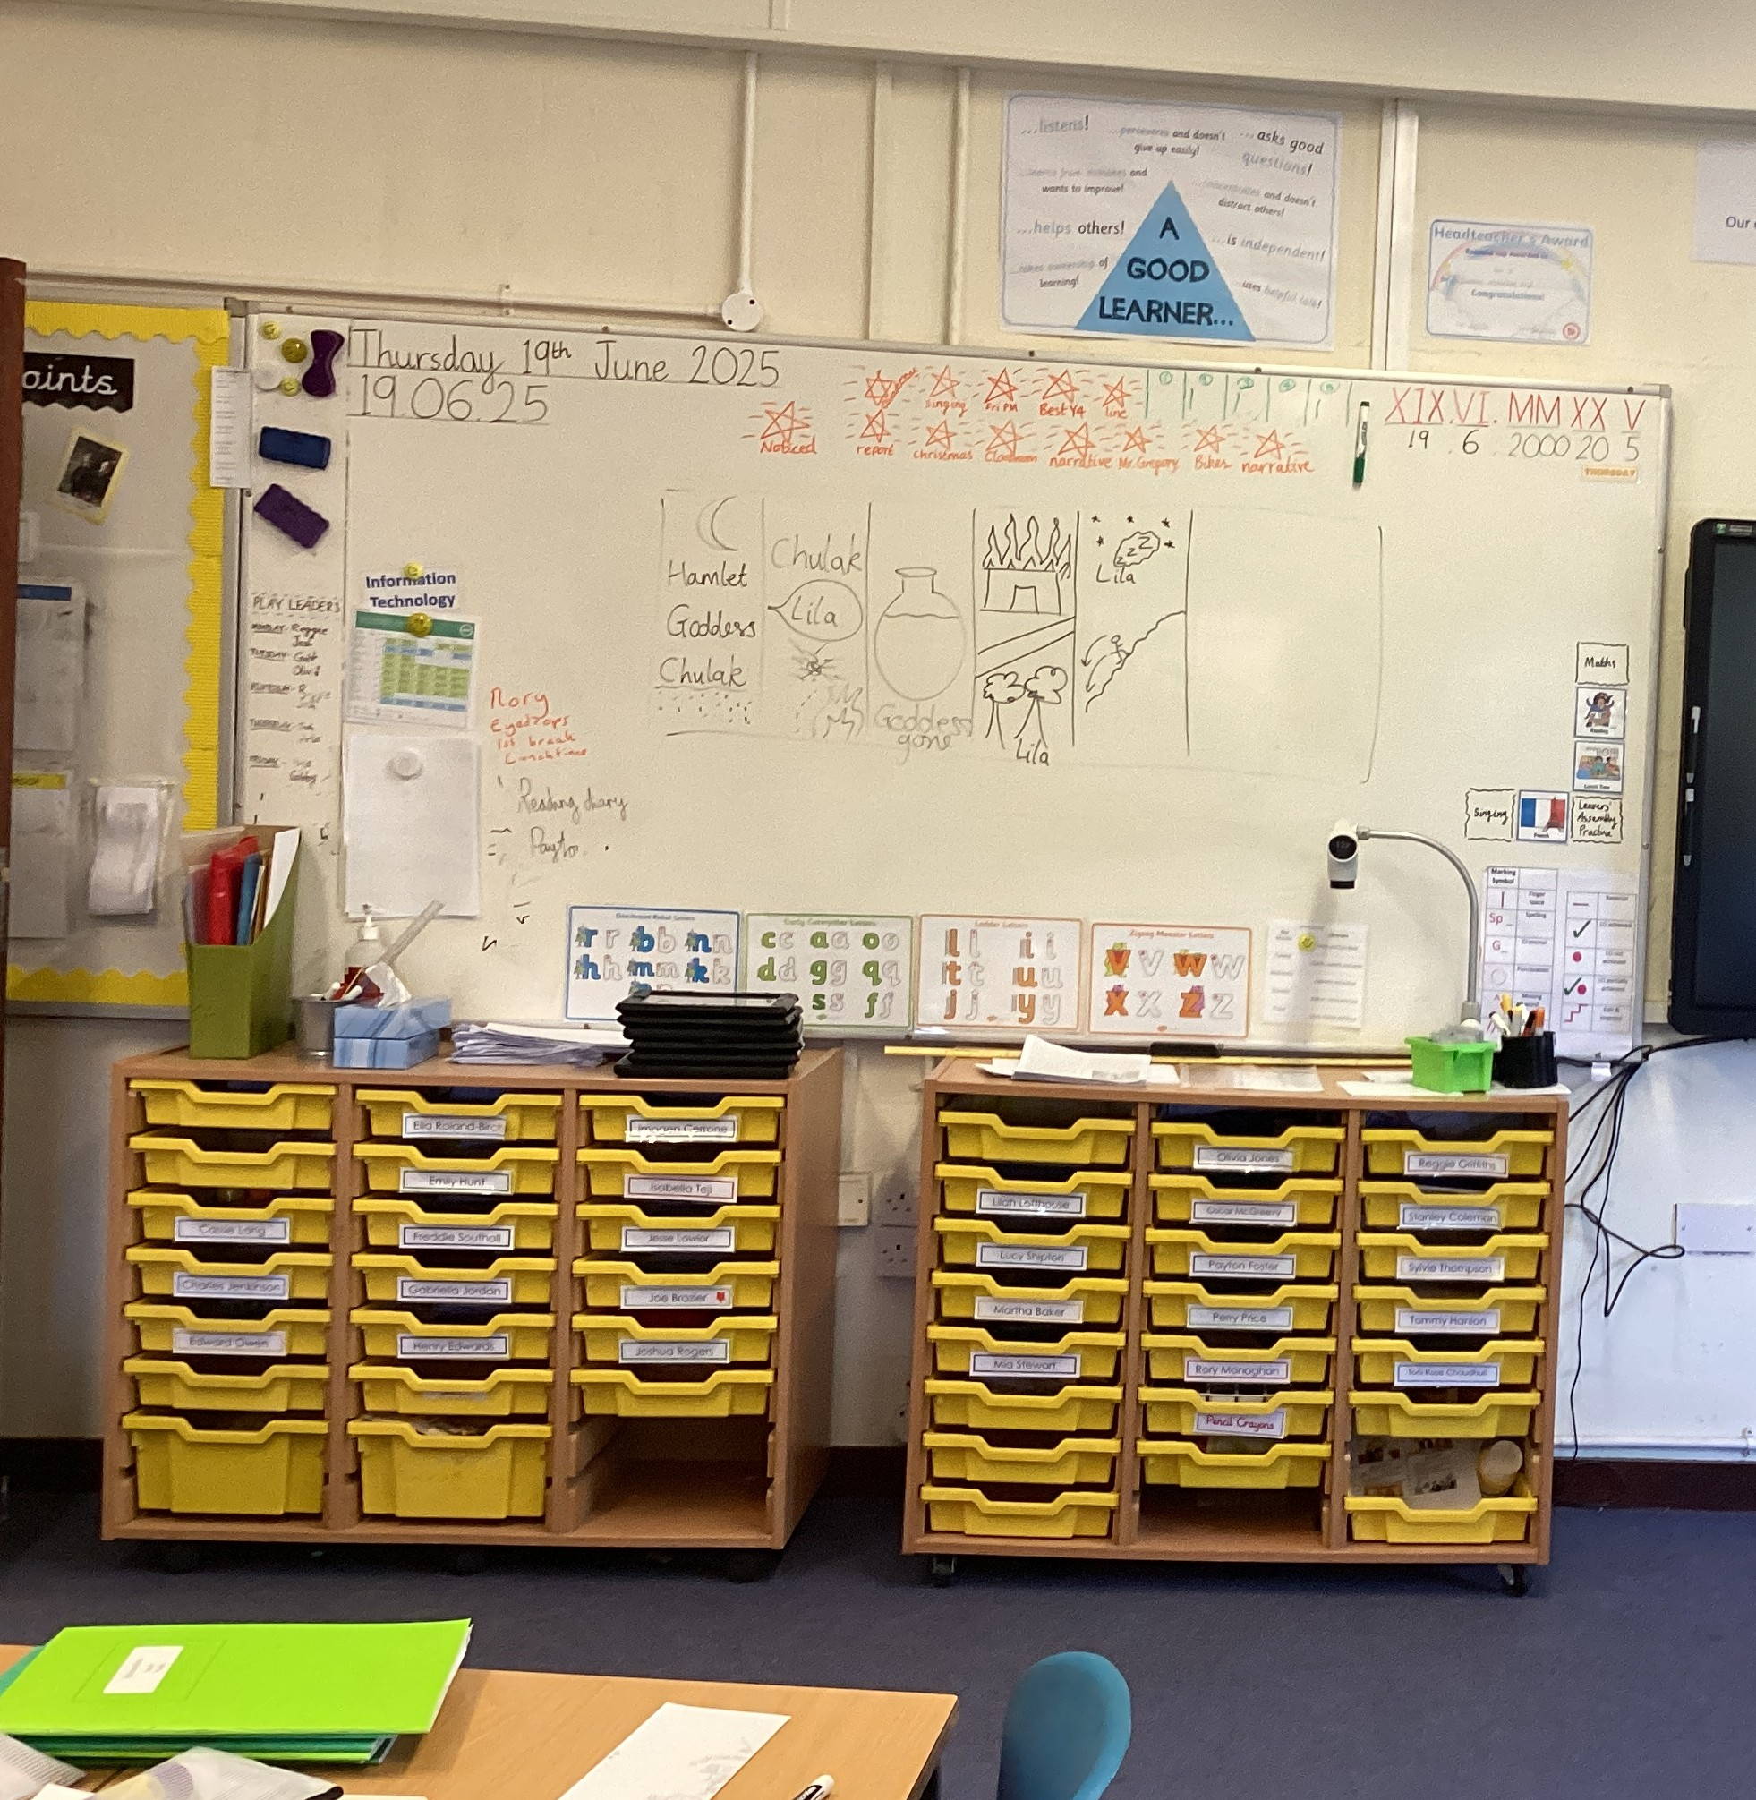

I will sit at tables like these:
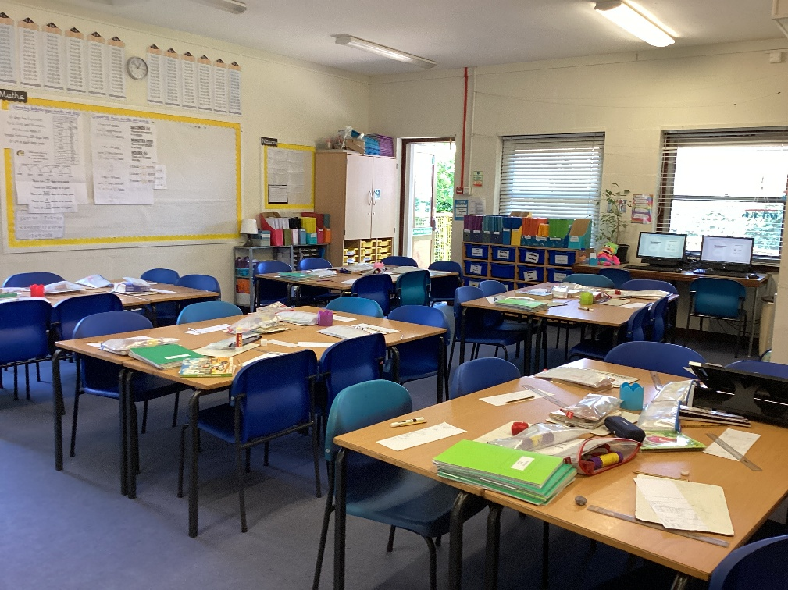

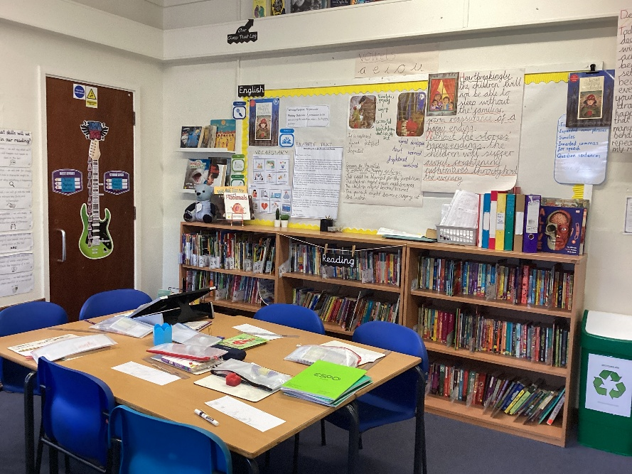
Here are some other pictures from my new classroom:

Our reading and browsing books

This is the whiteboard and interactive screen
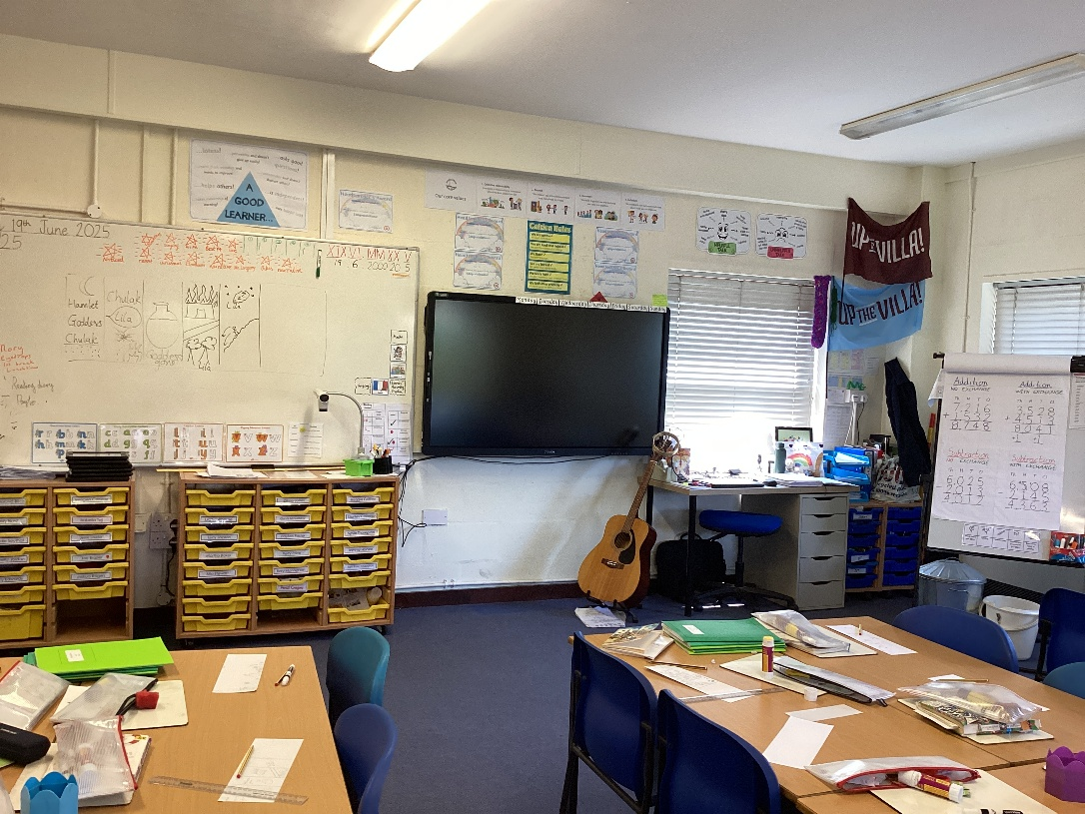

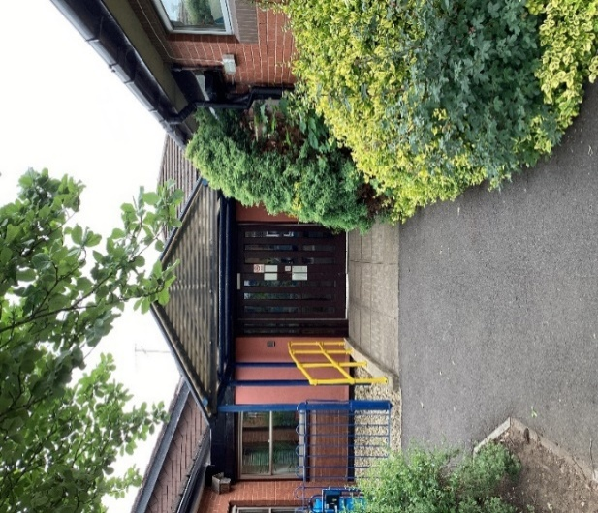
We come through the main door
every morning

Then this is the way out of the classroom at the end of the day.
You will walk down the ramp and will line up alongside the yellow fencing at home time.
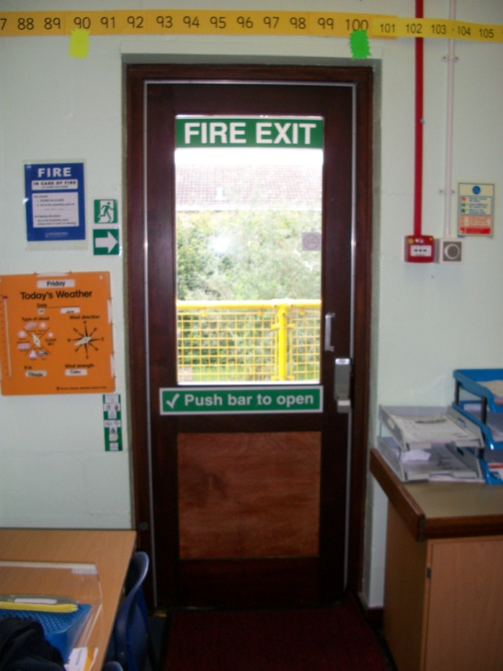
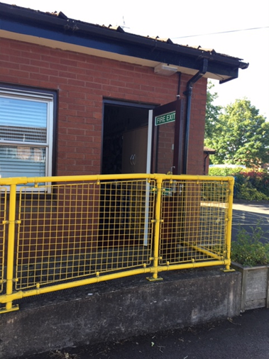

This page is for me to write any questions I might have about
Year 4.
………………………………………………………………………………………………………………………………………………………………………………………………………………………………………………………………………………………………………………………………………………………………………………………………………………………………………………………………………………………………………………………………………………………………………………………………………………………………………………………………………………………………………………………………………………………………………………………………………………………………………………………………………………………………………………………………………………………………………………………………………………………………………………………………………………………………………………………………………………………………………………………………………………………………………………………………………………………………………………………………………………………………………………………………………………………………….

Being in Year 4 will be FUN and EXCITING!!

